-REPORT TUTORIAL-

Cover sheet

Title sheet

Foreword

Summary

Content
Cover sheet 1
Title sheet 1
Foreword 1
Summary 1
Content 1
-0- Reports (tutorial) 1
-1- Types 5
-2- Beginning 7
Report sample introduction description 8
-3- Methodology 9
Report sample methodology description 9
-4- Results/Discussion 10
Reports sample discussion description 13
Linking words (tutorial) 14
-5- Integrate references 16
Direct quote description 16
Paraphrase description 16
Referencing sample 17
-6- Conclusion 18
-7- Example 19

-0- Reports (tutorial)

Research reports are the most common type of report in tertiary study. This tutorial outlines the requirements of the different sections of research reports.

Report Structure
The sample report used is only an abridged report for the purposes of modelling the different sections.
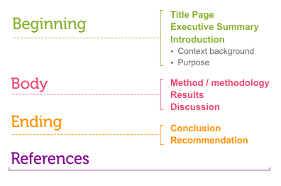
All reports have a beginning, a body and an ending. Reports based on research generally include the following sections:

Beginning
- Title page
This includes the title of report, your name and date.

- Executive summary
The executive summary is a summary of the whole report. It usually contains one sentence summarising each major section of the report.

- Introduction
The introduction provides context and background and clearly states the purpose of the report. It also outlines what will be covered in the following sections so the reader knows what to expect.

Body
Body covers what you found and what it means.

Ending
Conclusion and recommendations. Sums up what you found and makes recommendations.

Table of Contents
Table of Contents are used in longer reports and are written on a separate page. The following is a general guide to the structure of a research report. Note that all reports have a particular purpose so the format will often vary. The following sample Table of Contents uses a numbering system.

Sample 1 - Table Of Contents
Table of Contents
Title Page - separate page |  | TIP  Check course guide for specific course requirements
Table of Contents
- separate page
- for reports longer than a couple of page
Executive Summary  - seperate page | 2
1.0 Introduction | 3
1.1 Context
1.2 Purpose
1.3 Definitions
2.0 Main section of the report | 4
2.1 Literature review - if required  2.2 Methodology / method  2.3 Results / Findings  2.4 Discussion - interpretation of the results | 4  7  9  12
3.0 Conclusions | 14 | Headings and subheadings show where to find specific information
Summary of what was found
No new information
4.0 Recommendations | 15
Based on conclusions
Offering possible changes or solutions
5.0 Appendices | 17
Relevant additional material (e.g., surveys, questionnaires)  5.1  5.2 | 17  20 | Check that page and numbering are accurate
6.0 Bibliography / Reference List | 22

Sample 2 - Table Of Contents
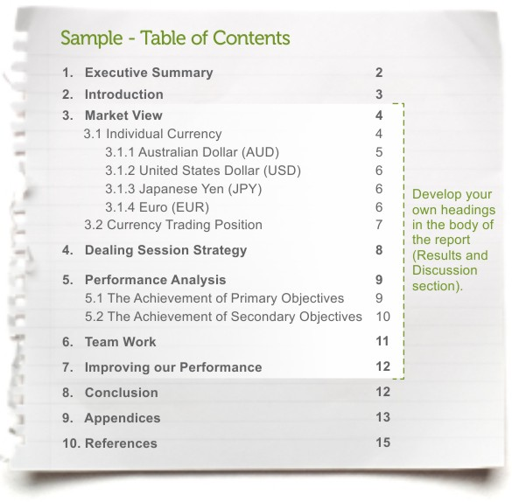

-1- Types

Common report structures
Short report | - Title page  - Introduction  - Discussion  - Recommendations  - References

Science report | - Title page  - Introduction  - Method & materials  - Results  - Discussion  - Conclusion  - Appendices  - References

Business report | - Title page  - Executive summary  - Table of contents  - Introduction  - Discussion  - Conclusion  - Recommendations  - Appendices  - References

Engineering report | - Title page  - Executive summary (optional)  - Introduction  - Objectives  - Analysis  - Discussion  - Recommendations & action plan  - Conclusion  - Appendices  - References

Research report | - Title page  - Executive summary  - Introduction  - Method/methodology  - Results/findings  - Discussion  - Conclusions  - Recommendations  - Appendices  - Bibliography

-2- Beginning

Executive Summary (Abstract)
An executive summary provides a quick overview or synopsis of a report, summarising the essential parts. It outlines the following information:
- the purpose of the report
- the methods used to conduct the research
- the result of the research
- the conclusions drawn from the research
- recommendations for future actions.
The executive summary/abstract is generally written last. This allows you to summarise all the major areas of the report.

Sample Executive Summary (Or Summary Or Abstract)
Purpose Method Results Conclusions Recommendations

The aim of this report was to investigate university teaching staff attitudes to the use of mobile phones by students in tutorials. A survey of teaching staff from each college was conducted in first semester of the academic year. Overall, the results indicate that the majority of staff found student mobile devices use a major disruption in tutorials. The report concludes that the predominant view of staff is that mobile phones are disruptive and should be turned off during tutorials. It is recommended that the university develops guidelines which would support staff in the restriction of student use of mobile phones in tutorials except in exceptional circumstances.

Text alternative report sample executive summary

Introduction
A good introduction is important in a report. It should give the reader all the information required to understand the importance and relevance of the report. It should clearly state:
- the context of the report
- the purpose of the report

Sample Introduction
Context Purpose

There has been a great increase in the use of personal mobile phones over the past five years with every indication that this usage will continue to increase. Indeed, widespread use of mobile devices in educational contexts for non educational purposes has been reported as distracting and disruptive to learning environments. Recently a number of university teaching staff have proposed that an institution wide policy be developed regarding student mobile phone use during tutorials and lectures. This report will discuss research into staff attitudes to the issue of student mobile phone usage in the teaching and learning environment.

Report sample introduction description
Legend: Context (bold) Purpose (italics)
There has been a great increase in the use of personal mobile phones over the past five years with every indication that this usage will continue to increase. Indeed, widespread use of mobile devices in educational contexts for non educational purposes has been reported as distracting and disruptive to learning environments. Recently a number of university teaching staff have proposed that an institution wide policy be developed regarding student mobile phone use during tutorials and lectures. This report will discuss research into staff attitudes to the issue of student mobile phone usage in the teaching and learning environment.

-3- Methodology

Method/Methodology
The method section of a report details how the research was conducted, the research methods used and the reasons for choosing those methods. It should outline:
- the participants and research methods used, e.g. surveys/questionnaire, interviews
- refer to other relevant studies.
The methodology is a step-by-step explanation of the research process. It should be factual and is mainly written in the past tense.

Sample Methodology
Describes how the research was done Refers to relevant reading/literature

The research used a quantitative methodology based on the approach advocated by Williams (2009). This study was conducted by questionnaire and investigated university teaching staff attitudes to the use of mobile phones in tutorials (see Appendix 1). The questionnaire used Likert scales to assess social attitudes (Jones 2007) to student mobile phone use and provided open ended responses for additional comments. The survey was voluntary and anonymous. A total of 412 questionnaires were distributed online to randomly selected staff from each of the three colleges within the university. The completed questionnaires were returned by email.

Report sample methodology description
Legend: Describes how the research was done (bold) Refers to relevant reading/literature (italics)
The research used a quantitative methodology based on the approach advocated by Williams (2009). This study was conducted by questionnaire and investigated university teaching staff attitudes to the use of mobile phones in tutorials (see Appendix 1). The questionnaire used Likert scales to assess social attitudes (Jones 2007) to student mobile phone use and provided open ended responses for additional comments. The survey was voluntary and anonymous. A total of 412 questionnaires were distributed online to randomly selected staff from each of the three colleges within the university. The completed questionnaires were returned by email.

-4- Results/Discussion

Results
The results section of a report details the results or findings of the research. It answers the following questions:
- What happened?
- What was found?
There is no interpretation of the results, it only states the facts.

Presenting The Data
Use visual data, e.g. tables and graphs to summarise the results and make them easy to understand. However, if visual data is used, they must be referred to in text. Dot points/bullet lists are also useful ways to present information.

Sample Results
There was an 85% response rate to the distribution of questionnaires to staff. The results clearly show that student mobile phones are considered by teaching staff to be disruptive (see Table 1). As a result, most staff would prefer that mobile phones were turned off in tutorials.
Table 1
MOBILE PHONE USE IN TUTORIALS | STRONGLY AGREE % | AGREE % | DISAGREE % | STRONGLY DISAGREE %
1. Not a problem | 5 | 7 | 65 | 23
2. Sometimes a problem | 40 | 45 | 10 | 5
3. Often a problem | 80 | 10 | 7 | 3
4. Phones should be allowed | 6 | 16 | 56 | 22
5. Phones should be turned off | 85 | 10 | 3 | 2
6. Phones should be allowed in some circumstances | 10 | 52 | 24 | 14

NB: Tables must be referred to in the text.

tip
Label figures below and tables above.
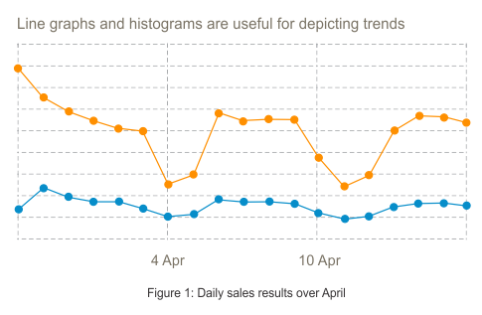
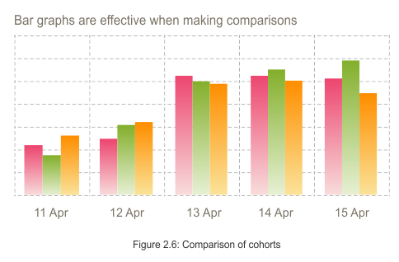
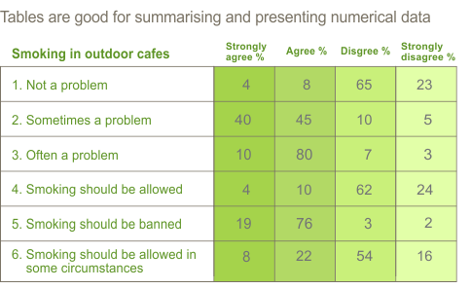

Discussion
The discussion section of a report interprets the results of the research. It is here that the findings are woven together and the major issues/themes are identified and discussed.
The discussion section aims to:
- state/identify the main research findings/themes
- interpret and weave the results together to show what they mean
- link the results to other research.
Identifying the major themes in the results will help structure the discussion, especially in long reports. These can often be used as headings.

Sample Discussion Paragraph
Discussion of results Link to other research Student analysis/comment

Another significant finding of this study was that 80% of respondents found mobile phones are distracting in learning environments. This result differs from other similar studies. According to Lau (2011), staff were increasingly using mobile technologies in tutorials and saw them as a valuable addition to the classroom. Further to this, mobile technology has the potential to become a critical tool for teaching (Bond 2010).This difference suggests that the technology can be used effectively if it is integral to the learning process. However, if it is used as a distracting social tool in a tutorial, control of its use is justified.

Text alternative sample discussion

Reports sample discussion description
Legend: Discussion of results (bold) Link to other research (italics) Student analysis/comment (bold and italics)
Another significant finding of this study was that 80% of respondents found mobile phones are distracting in learning environments. This result differs from other similar studies. According to Lau (2011), staff were increasingly using mobile technologies in tutorials and saw them as a valuable addition to the classroom. Further to this, mobile technology has the potential to become a critical tool for teaching (Bond 2010). This difference suggests that the technology can be used effectively if it is integral to the learning process. However, if it is used as a distracting social tool in a tutorial, control of its use is justified.

Integrating References
There are two useful strategies for including references in your writing:
- Reporting words/phrases
- Linking words/phrases.
Choosing the most appropriate reporting words is important as it represents the original writer by showing the degree of certainty of their opinion or findings. When using words from the following list, be aware that their meanings all differ.

Reporting Words/Phrases
Suggest(s) (that) | Maintain(s) (that)
Argue(s) (that) | Found (that)
According (to) | Promote(s)
Outline(s) | Establish(ed) by
Focus(es) on | Asserts (that)
Define(s) | Show(s)
Conclude(s) (that) | Claim(s) (that)
State(s) | Report(s)
Mention(s) | Address(es)

Linking Words
Linking words enable the writer to show the connections between ideas. We use linking words to emphasise the writer’s analysis of their research.
Examples
Firstly,
Furthermore,
In addition,
However,
In contrast,
Consequently,

Linking words (tutorial)
Linking words are used to connect ideas when writing. They enable the writing to flow from one idea to the next in a logical and cohesive way. They are words like; however, first, for example and consequently.

Develop cohesion
Linking words are an important way of developing a logical flow of ideas. They act as signposts for the reader so they can follow the way the writer has organised their ideas.

Example
In the text below notice how the writer uses linking words to develop the flow of their argument.

Do teams in organisations need leaders?
How and why the leader was selected also appears to affect the leader’s effectiveness. For example, Maxwell (2011) asserts that teams work better if they elect their own leader. However, Smith’s research (2010) shows that team leaders are mainly selected on a hierarchical basis. Furthermore, in most cases when leaders were not elected democratically, team members reported a lack of confidence in their leaders’ competence and knowledge.

Show connections between the ideas
Linking words enable the writer to show the connections between ideas. In the next example notice how the use of linking words emphasises the writer’s analysis of their research.

Example
One factor within the team that seems to be important is the notion of team cohesiveness. Significantly, team cohesiveness enables a diverse group of individuals to work towards common goals. Maxwell (2011, p.107) argues that highly cohesive teams ‘have clear goals and successful outcomes’. For example, cohesive teams are more likely to work well together, have enthusiasm for their work (Brown 2009) and so achieve a high rate of success (Zheng & Hui 2008). Therefore, team cohesiveness has been shown to enhance team effectiveness.

-5- Integrate references

Academic writing involves using references and integrating them into your writing. This shows that you understand what you have read and can compare the ideas of different authors.
There are two ways to include references in your writing:
- direct quote
- paraphrase.
Note: This tutorial uses the Harvard Referencing System from the Commonwealth of Australia 2002,Style manual for authors, editors and printers, 6th edn, John Wiley & Sons, Australia.
Always check your Course Guide for the correct referencing style to use.

Direct quote and paraphrase
Notice the page number in the direct quote and the difference in punctuation.

Direct Quote
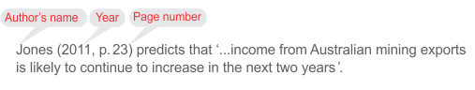
Text alternative direct quote

Direct quote description
Legend: Author's name (bold) Year (italics) Page number (bold and italics)
Jones (2011, p 23) predicts that'...income from Australian mining exports is likely to continue to increase in the next two years'.

Paraphrase
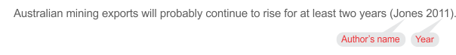
Text alternative paraphrase

Paraphrase description
Legend: Author's name (bold) Year (italics)
Australian mining exports will probably continue to rise for at least two years (Jones 2011).

Example direct quotes and paraphrases
In the sample paragraph below notice how the writer uses three types of sentences:
- Sentences in the writer's own words
- Sentences that contain a direct quote
- Sentences that paraphrase

Topic sentence Paraphrase Direct quote Writer's words

How the team leader is selected also appears to affect the effectiveness of the team. The selection of the team leader is part of establishing roles within the team. It has been asserted that if a leader is elected democratically by the team and from within the team, there is more likelihood of an effective working relationship between team members (Allen & Lee 2009; Searson 2011). However, Taylor (2010, p. 56) noted that more than 60% of 350 workplace teams studied, operate with team leaders chosen by middle or upper management. Further, in more than half of these, the team leaders 'did not have the confidence of the team members to the extent that effectiveness and efficiency (and thus, productivity) was compromised' (Taylor 2010 p. 56). Therefore, leader selection needs to come from within the team.

Text alternative referencing sample

Referencing sample

Legend: Topic sentence (bold) Paraphrase (italics) Direct quote (bold and italics) [Writer's words]
How the team leader is selected also appears to affect the effectiveness of the team. The selection of the team leader is part of establishing roles within the team. It has been asserted that if a leader is elected democratically by the team and from within the team, there is more likelihood of an effective working relationship between team members (Allen & Lee 2009; Searson 2011). However, Taylor (2010, p.56) noted that more than 60% of 350 workplace teams studied, operate with team leaders chosen by middle or upper management. Further, in more than half of these, the team leaders 'did not have the confidence of the team members to the extent that effectiveness and efficiency (and thus, productivity) was compromised' (Taylor 2010 p.56). [writer's words]Therefore, leader selection needs to come from within the team.[end writer's words]

-6- Conclusion

Conclusion
The conclusion summarises the main findings of the report and presents 'an answer'. No new information should be put in a conclusion.

Sample Conclusion
The student use of mobile phones in tutorials is clearly intrusive to teaching staff and detrimental to learning environments in general. The study highlights the concerns of teaching staff with regard to mobile phone usage. The fact that the majority of staff view the student use of mobile phones in tutorials as disruptive suggests appropriate guidelines and policies need to be developed.

Recommendations
The recommendations section suggests suitable actions, outcomes, changes or solutions to the problem(s) identified in the research. Point form maybe used to list the recommendations. Always check your Course Guide.

Language Of Recommendations
Tentative language is useful for making recommendations. Use words such as ‘should’, ‘could’, ‘may’. Recommendations often start with 'It is recommended that...'

Sample Recommendations
It is recommended that the university develops official guidelines regarding the use of mobile phones in tutorials. The guidelines should recommend:
- Teaching staff have the right to restrict mobile phone usage according to their discretion.
- Mobile phones may only be used by students in exceptional circumstances.
Finally, the guidelines need to be university wide and clearly communicated to all staff and students.

-7- Example

Sample report
 | Executive Summary (Or Summary Or Abstract )
PurposeMethodResultsConclusionsRecommendations | The aim of this report was to investigate university teaching staff attitudes to the use of mobile phones by students in tutorials. A survey of teaching staff from each college was conducted in first semester of the academic year. Overall, the results indicate that the majority of staff found student mobile devices use a major disruption in tutorials. The report concludes that the predominant view of staff is that mobile phones are disruptive and should be turned off during tutorials. It is recommended that the university develops guidelines which would support staff in the restriction of student use of mobile phones in tutorials except in exceptional circumstances.
 | Introduction
ContextPurpose | There has been a great increase in the use of personal mobile phones over the past five years with every indication that this usage will continue to increase. Indeed, widespread use of mobile devices in educational contexts for non educational purposes has been reported as distracting and disruptive to learning environments. Recently a number of university teaching staff have proposed that an institution wide policy be developed regarding student mobile phone use during tutorials and lectures. This report will discuss research into staff attitudes to the issue of student mobile phone usage in the teaching and learning environment.
 | Method
Refer to relevant reading/literatureDescribe how the research was done | The research used a quantitative methodology based on the approach advocated by Williams (2009). This study was conducted by questionnaire and investigated university teaching staff attitudes to the use of mobile phones in tutorials (see Appendix 1). The questionnaire used Likert scales to assess social attitudes (Jones 2007) to student mobile phone use and provided open ended responses for additional comments. The survey was voluntary and anonymous. A total of 412 questionnaires were distributed online to randomly selected staff from each of the three colleges within the university. The completed questionnaires were returned by email.

TIP
Check your course guide for appropriate referencing style.
 | Results
Facts only- no interpretation. | There was an 85% response rate to the distribution of questionnaires to staff. The results clearly show that student mobile phones are considered by teaching staff to be disruptive (see Table 1). As a result, most staff would prefer that mobile phones were turned off in tutorials.
 | Table 1
Tables must be referred to in the text | 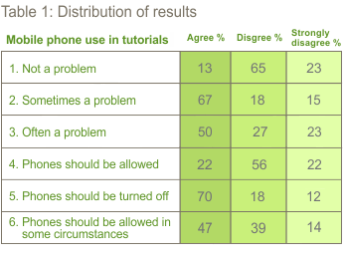
 | Discussion
Discuss and interpret the meaning of the results  Integrate different findings to create meaning  Link results to other research | It is evident from the results in Table 1 that student mobile phone use in tutorials is considered to be a significant problem; however it was acknowledged that in some cases it should be permissible. Given that such high numbers of teaching staff (85 %) consider that student mobile phone usage in tutorials is a problem, clearly this is a teaching issue that needs to be addressed. Further, while the findings acknowledge a place for mobile phones in exceptional circumstances (62%) it would appear that a policy is required to make explicit acceptable guidelines for their usage.  These findings are consistent with a number of other studies. According to Smith (2009) many educational institutions have identified mobile phones as disruptive to learning.Watts(2010) also claims that up to 30% of tutorial time is wasted through unnecessary phone interruptions. Other similar research shows ….  Another significant finding of this study was that 80% of respondents found mobile phones distracted from the learning environment. This result differs from other similar studies. According to Lau (2011), staff were increasingly using mobile technologies in tutorials and saw them as a valuable addition to the classroom. Further to this, mobile technology has the potential to become a critical tool for teaching (Bond 2010). This difference suggests that the technology can be used effectively if it is integral to the learning process. However, if it is used as a distracting social tool in a tutorial, control of its use is justified.

TIP
For Results and Discussion develop headings appropriate for your content
 | Conclusion
Summary of main findings and ‘the answer’ | The student use of mobile phones in tutorials is clearly intrusive to teaching staff and detrimental to learning environments in general. The study highlights the concerns of teaching staff with regard to mobile phone usage. The fact that the majority of staff views the student use of mobile phones in tutorials as disruptive suggests appropriate guidelines and policies need to be developed.
 | Recommendations
Suggest possible changes/solutions.  Point form can be used. | It is recommended that the university develops official guidelines regarding the use of mobile phones in tutorials. The guidelines should recommend that:  - teaching staff have the right to restrict mobile phone usage according to their discretion  - mobile phones may only be used by students in exceptional circumstances.  Finally, the guidelines need to be university wide and clearly communicated to all staff and students.
Attachments | Appendices

TIP
Use point form for lists. Check your course guide.

